|  |
| --- |
| BVN Account Registration Portal  *User Guide* |
| Version:1.0  Date: 12  Status: Approved  Classification:  Level: 1  Subject: BVN Account Registration Portal User Guide  Reference: NIBSS/2015/0612 |

Technical Data

|  |  |
| --- | --- |
| Reference |  |
| Document Title: | BVN Account Registration Portal User Guide |
| Version: | 1.0 |
| Status: | Approved |
| Classification: | Restrict |
| Document type: | Docu |
| Document level: | 0 |
| Subject: | Registration |
| Responsible area: | Quality |
|  |  |

Authors and Participants

|  |  |  |
| --- | --- | --- |
| **Name** | **Contact** | **Function** |
|  |  | Elaboration |
|  |  | Revision |
|  |  | Approval |

Distribution List

|  |
| --- |
| **Name** |
|  |

Revisions

|  |  |  |  |
| --- | --- | --- | --- |
| **Version** | **Data** | **Description** | **Author** |
|  |  |  |  |

Table of Contents Page

Login screen…………………………………………………………………………………..4

Default Password Change…………………………………………………………………...4

Portal Navigation Screen…………………………………………………………………….6

Switching Between Portals...………………………………………………………………...7

Adding a New Account…………………………………………………………….……......8

Adding Multiple Accounts…………………………………………………………………10

Registered Accounts………………………………………………………………………...11

***Login Screen***

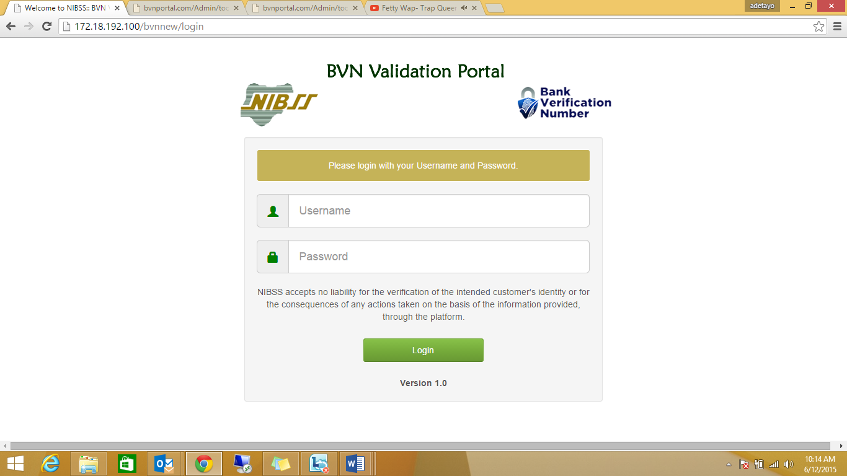

Enter your username and password in the spaces provided.

***Default Password Change*** 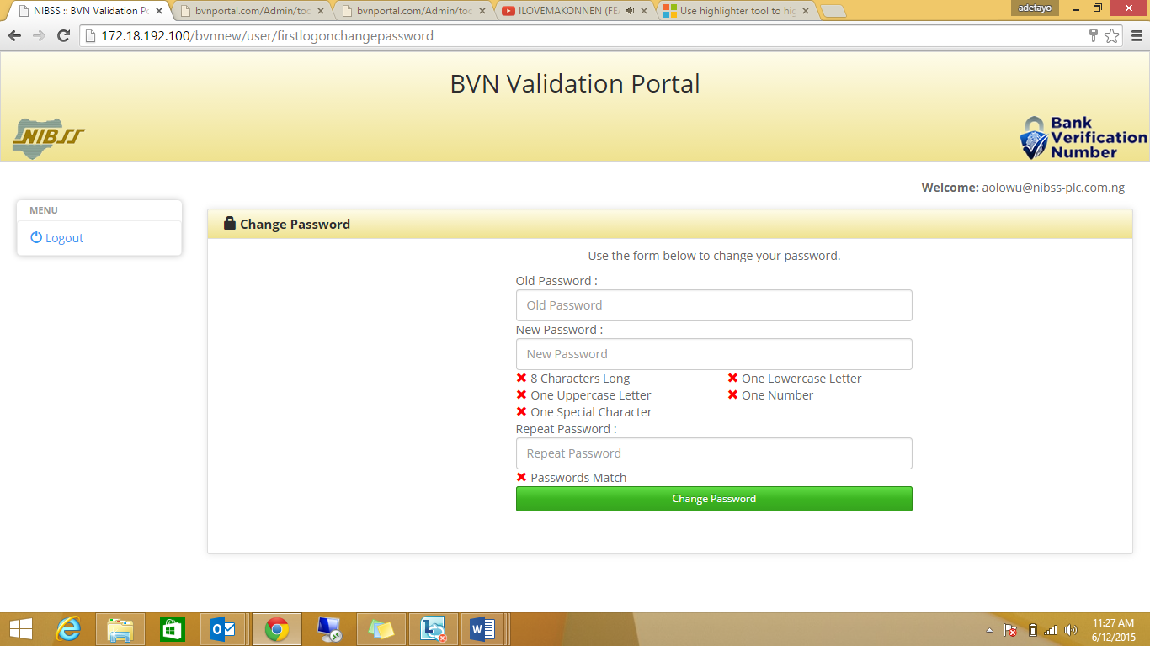

Change default password at first log in. Once password requirements are satisfied, the red ticks change to green as shown below.

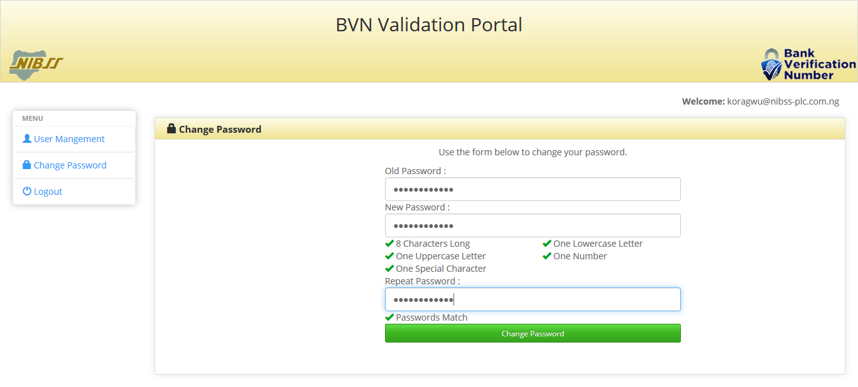

Click on **‘Change Password’** to complete password change

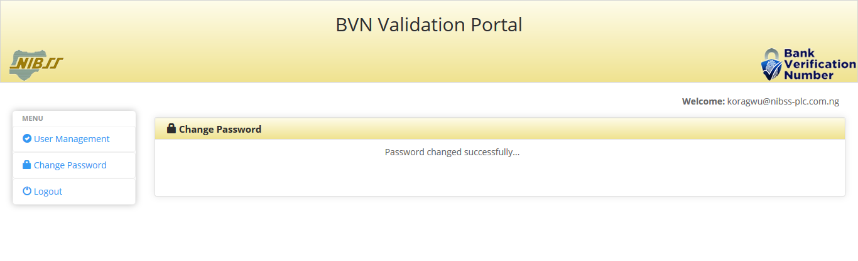

Password has been changed successfully

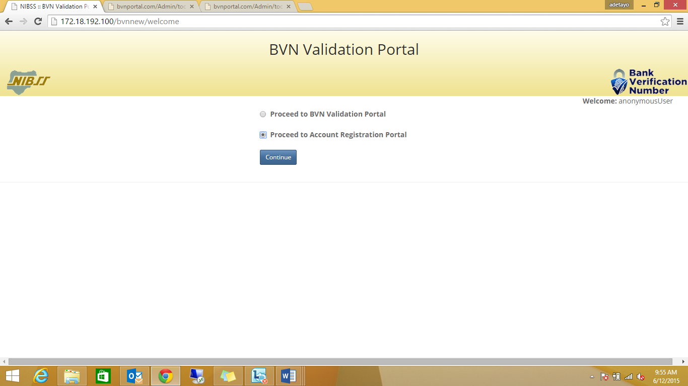***Portal Navigation Screen***

Select **‘Proceed to Account Registration Portal’** and click on continue

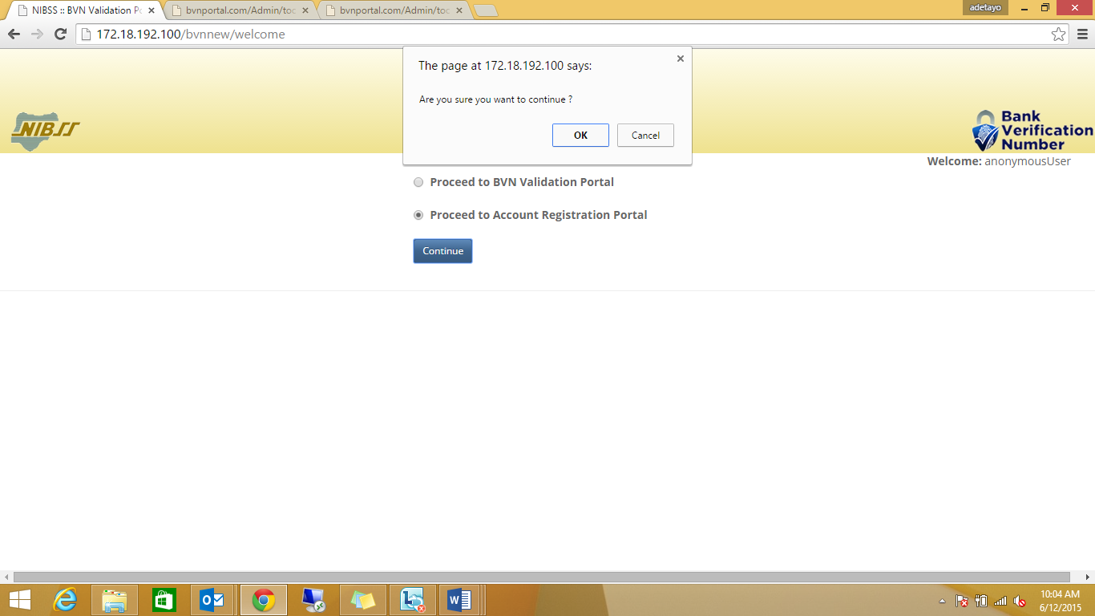

A dialog box is displayed at the top of the page. Select ‘**OK’** to continue to the portal

***Switching Between Portals***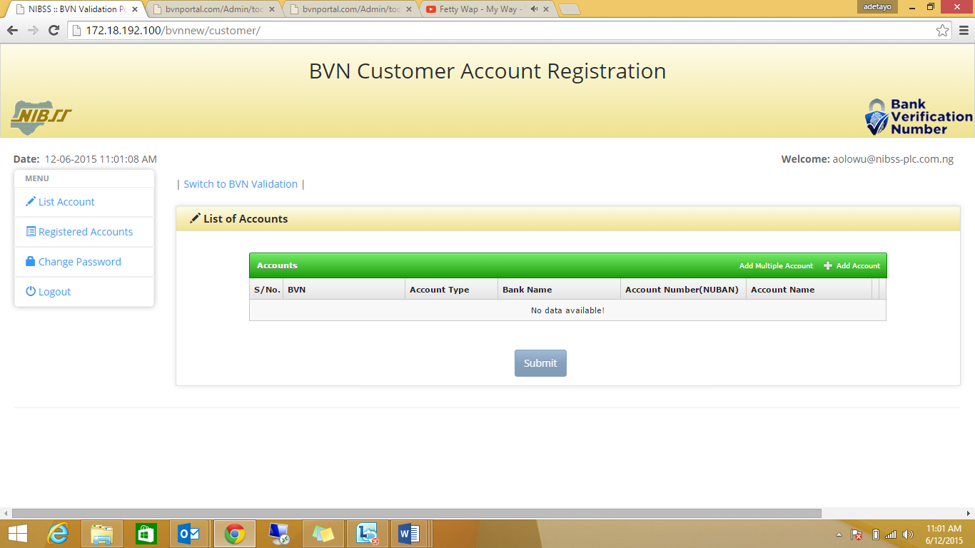

Click on switch to **‘BVN Validation’** to switch to the BVN Validation Portal.

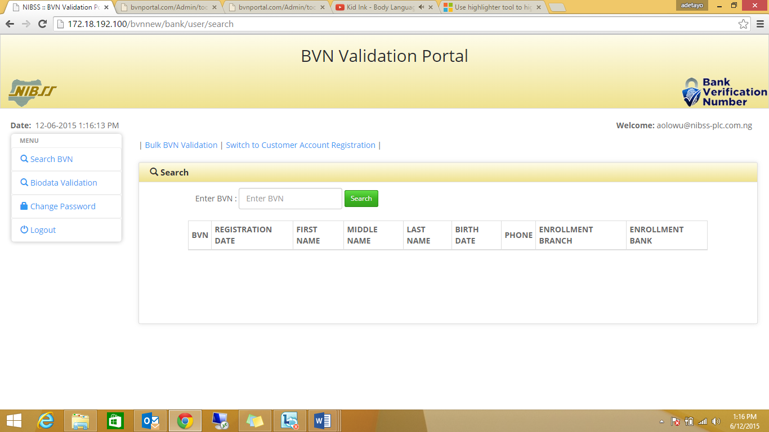

Click on switch to **‘Customer Account Registration’** to switch to the Account Registration portal.

***Adding a new account***

Click **“+ Add Account”** at top right corner of the accounts table to add a new account. A dialog box is displayed as shown below

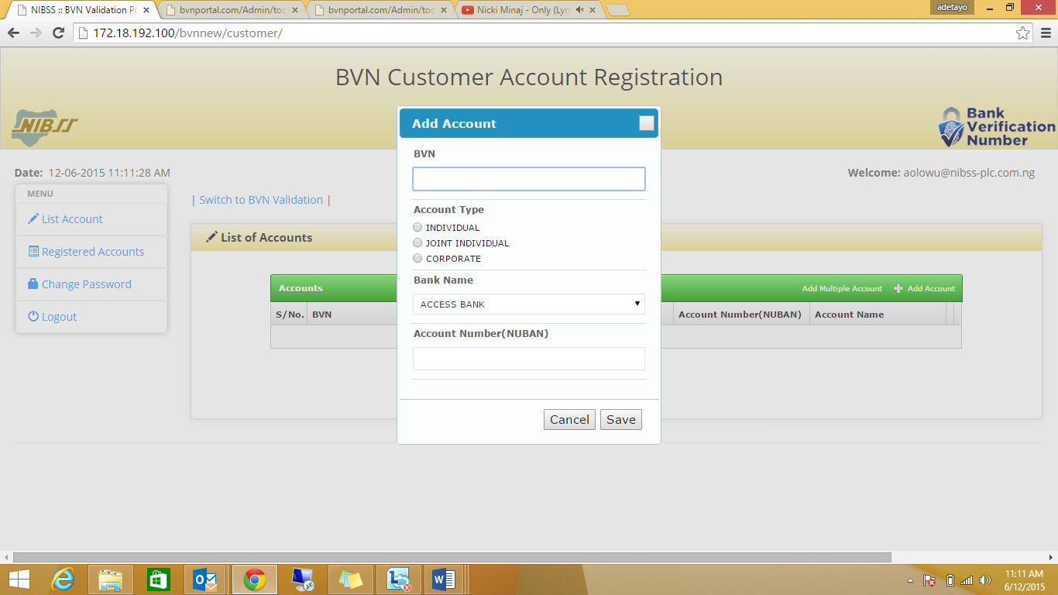

Fill in the customer details in the spaces provided. All fields are mandatory

**Note:** For Joint and Corporate Accounts, you are required to input the Accountname note that

Account number must be NUBAN.

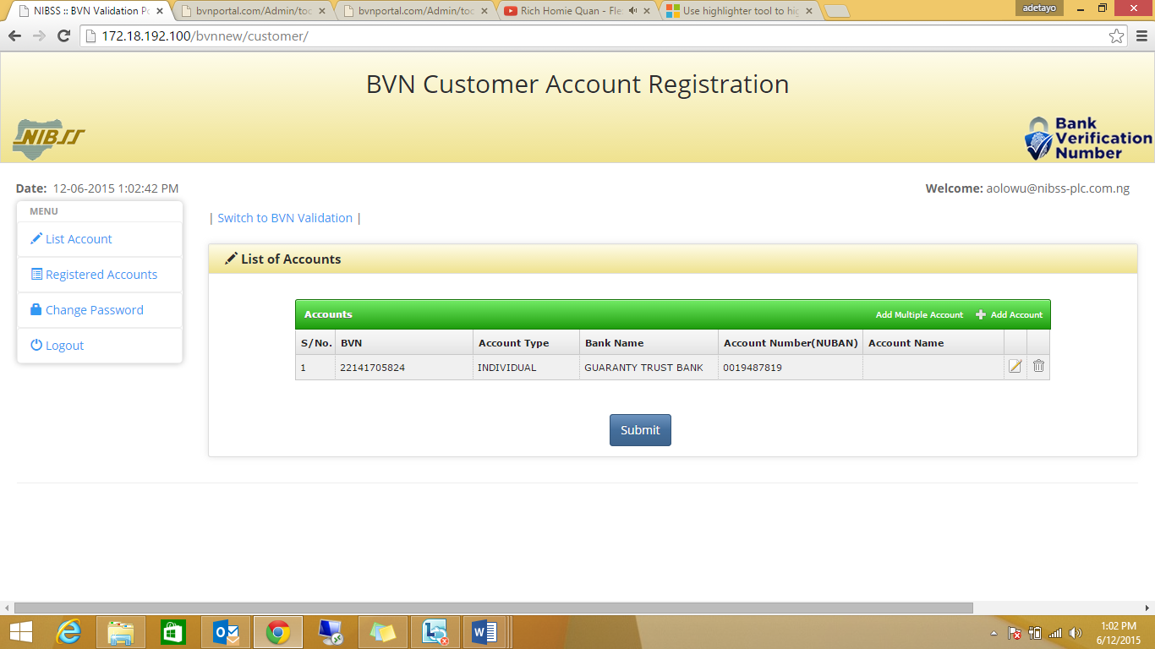

Click on ‘Submit’ to register the accounts for linking. This saves all data provided into the database

A dialog box is displayed as shown below

**Note:** You can only edit or delete the account information before submission, by clicking on the icons highlighted in the table above.

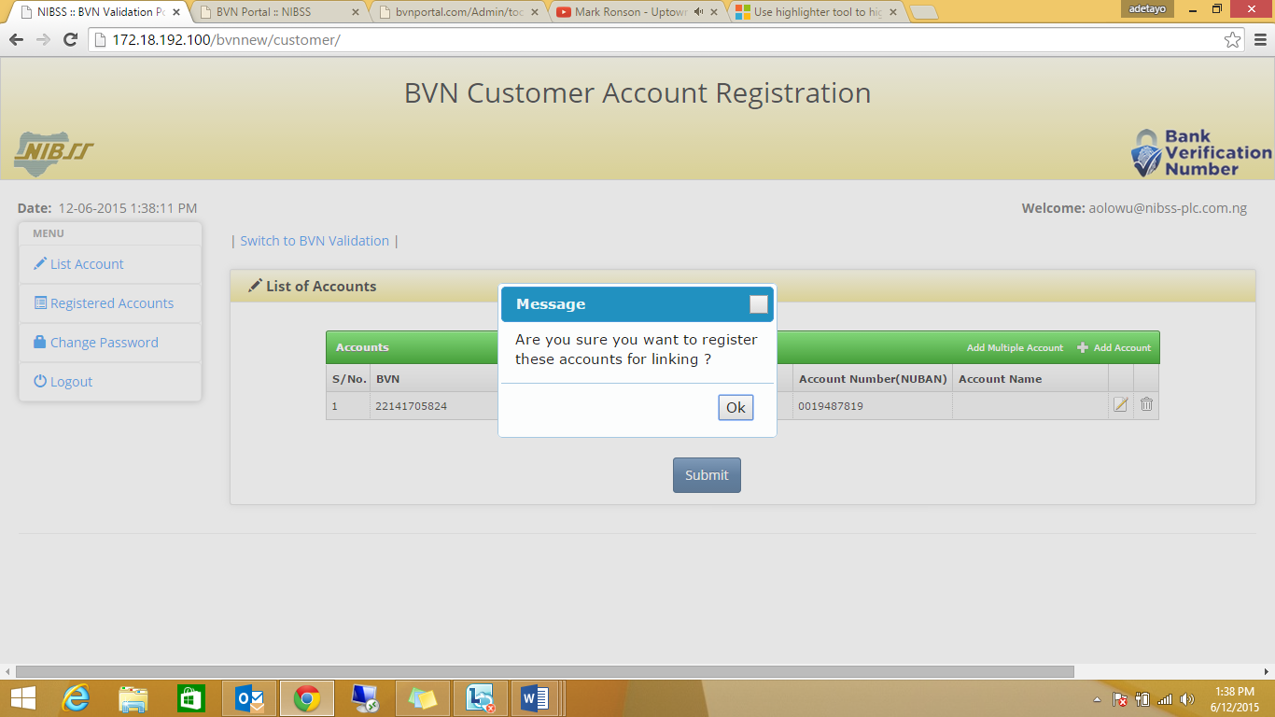

Click on ‘**OK’** to successfully register an account for linking

***Adding Multiple Accounts***

Click **“Add Multiple Account”** at top right corner of the accounts table to add multiple accounts. A dialog box is displayed as shown below

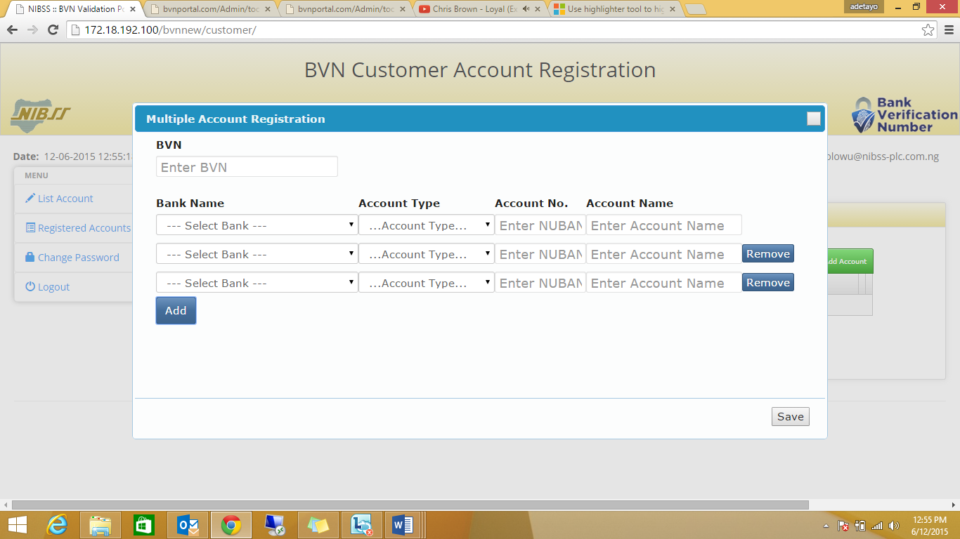

Fill in the customer details in the spaces provided. All fields are mandatory

Click on **‘Add’** or **‘Remove’** to insert a new line or delete a line.

***Registered Accounts***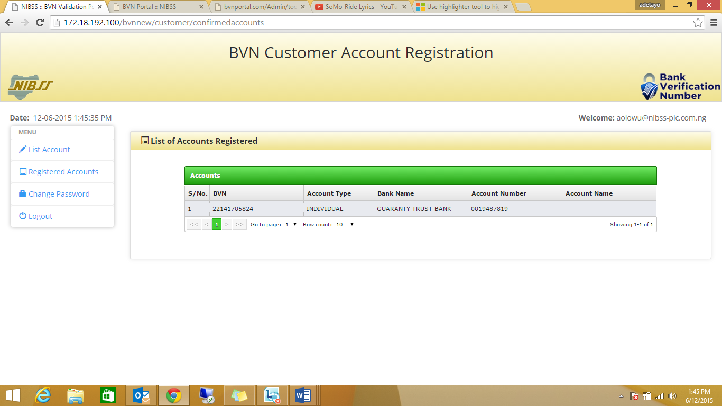

Click on **‘Registered Accounts’** to view all accounts that have been registered for linking.